Dasboard requirements

- In this dashboard we just need 1 module at this stage
-> Car wash orders (module)
-> with three indicated statuses ,,,
-> need all the columns of this module
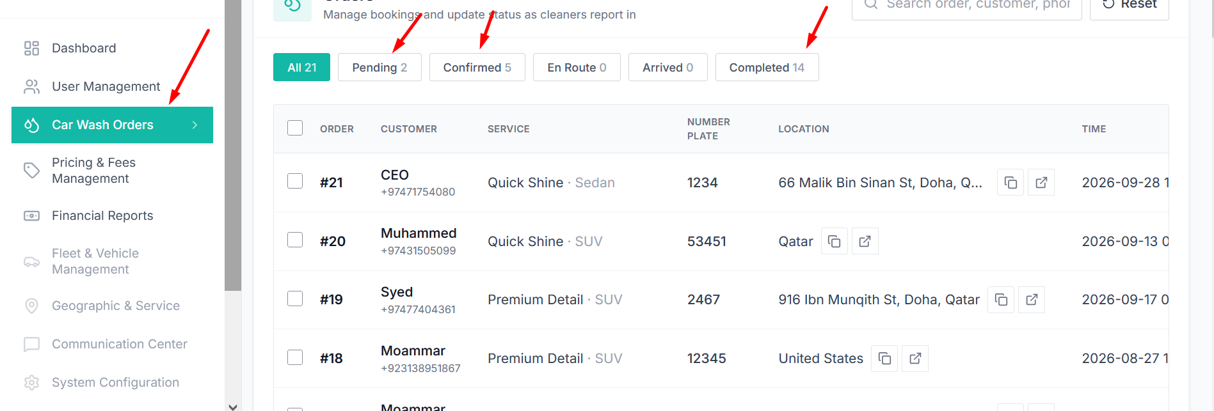
- User or manager should able to enter the data manually of their users
- Will add more features with time ,,,

